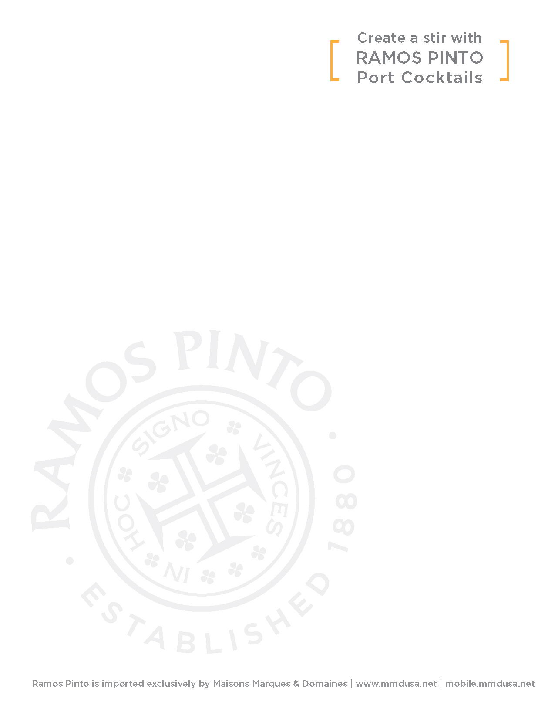

.5 oz Ramos Pinto White Port

.5 oz Orange Bitters

.5 oz Elderflower Liqueur

.5 oz Fresh Lime Juice

3 dashes Grapefruit Bitters

Shake, strain into chilled cocktail glass, garnish with lemon or orange peel.

1 part Ramos Pinto White Port

2 parts Aperol

2-3 drops Orange Bitters

Splash of soda

Garnish with burnt orange peel

2 oz Ramos Pinto White Port

½ oz Cynar 70

¾ oz Fresh Lemon Juice

½ oz Honey Water

Splash Angostura Bitters

Served on the rocks | Garnish with cilantro