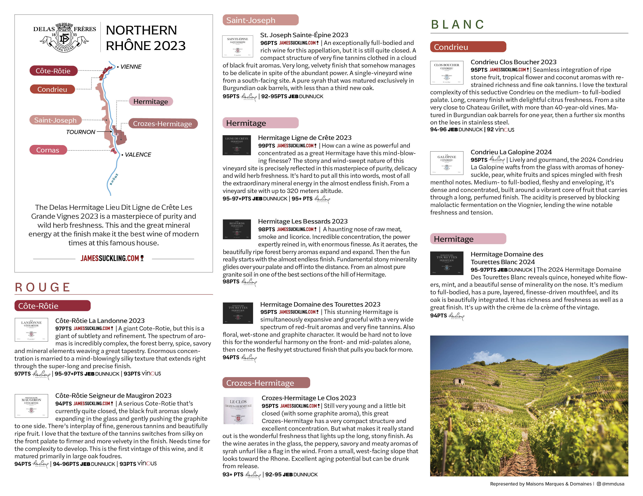
$00
$00
$00
$00
$00
$00
$00
$00
$00
$00

