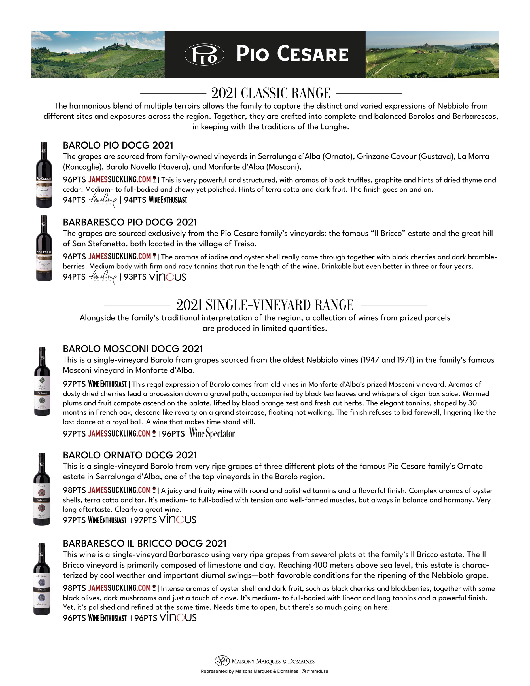
$0.00
$0.00
$0.00
$0.00
$0.00

