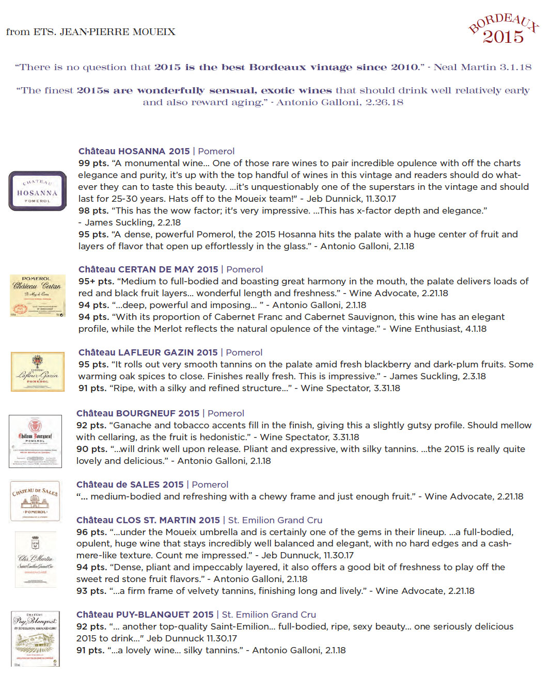­

­­

Exclusively imported by Maisons Marques & Domaines | www.mmdusa.net